SOCKET Programming PYTHON

SOCKET :
It is a gateway through which a computer program can send and receive data over a network

TWO Types of Socket :

1 . Stream Socket (TCP )
2 . Datagram Socket ( UDP )

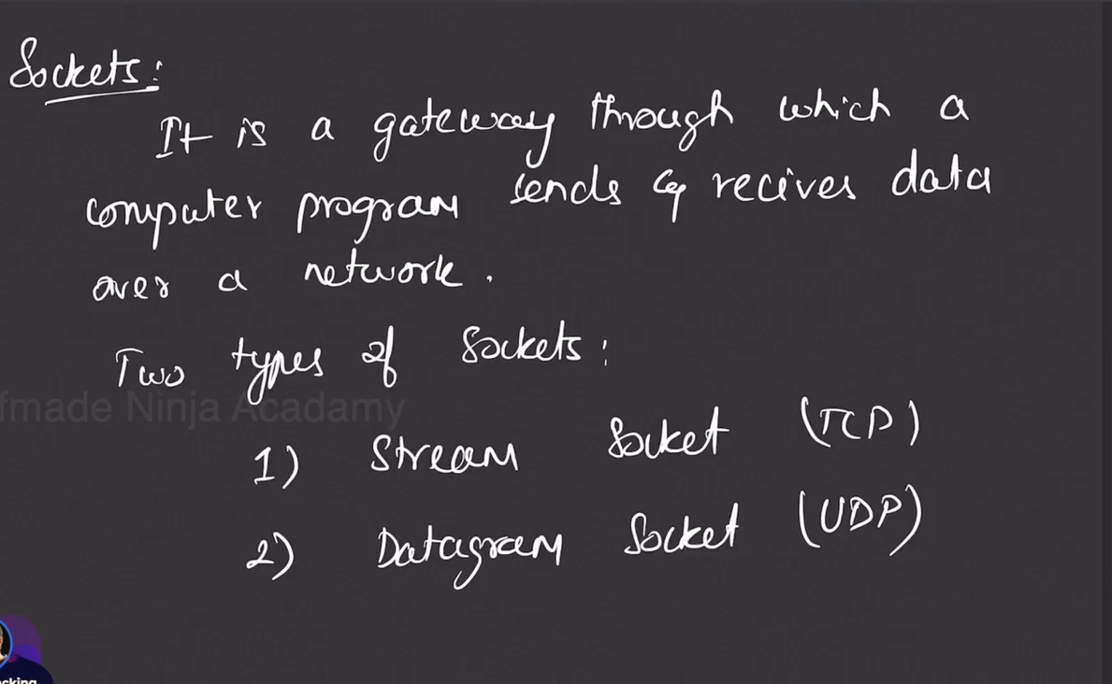
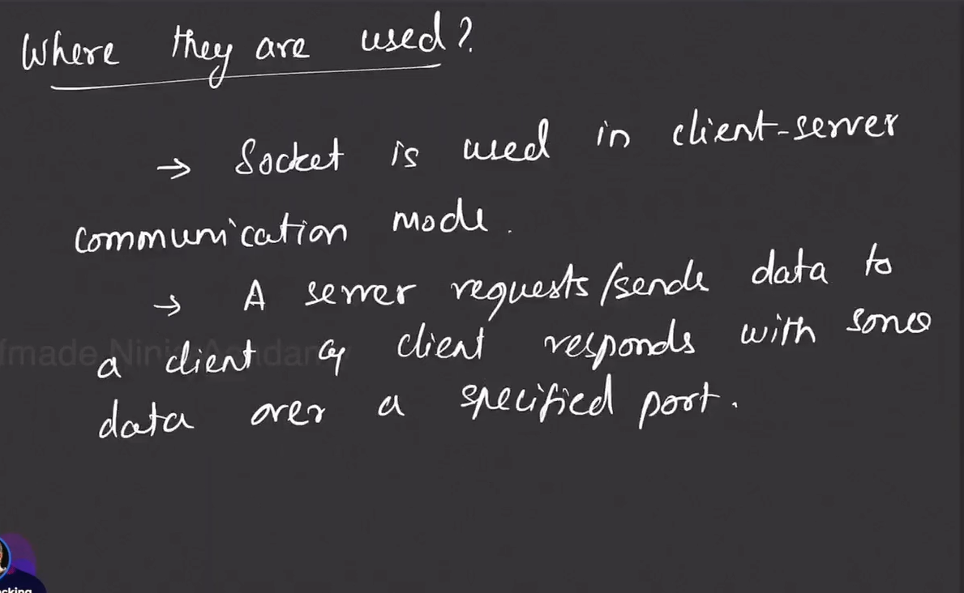

SERVER Side

Socket can initilize using API . API used to create interface or communicate with other service .

( Important )
For any type of communication make by Computer custom , by using socket . ex : bluetooth headset etc ...

( 6 methods is used )

1 . socket ( ) => initilize the socket

2 . bind ( ) => it will bind the Port number and IP address . once we bind something that port number is locked . We cannot use the port number for another app . Because of bind . the program bind itself with port number .

3 . listen ( ) => it can listen for incoming communication .

4 . accept ( ) => it will accept the communication

5 . receive ( ) / send ( ) = > it will receive and send

6 . close ( ) = > close the connection .

CLIENT Side

(4 methods )

1 . socket ( ) => initilize the socket

2 . Connect ( ) => A server when it is ready to accept the connections .
Arrow to serverside 4 . accept ( ) .

3 . receive ( ) / send ( ) = > it will receive and send

4 . close ( ) = > close the connection .

